SCHOOL CATALOG
Ohio Registration # 14-12-2055T
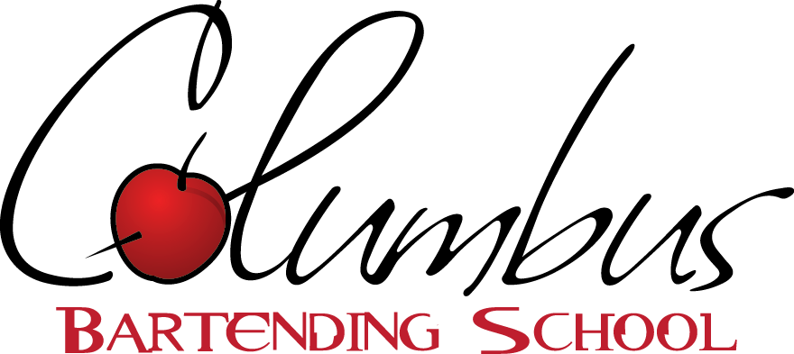
5354 North High Street, Columbus, OH 43214
*Member of the Professional Bartending Schools of America Network

July 2, 2018

Columbus Bartending School offers an excellent Bartending program with first-rate training facilities and great amenities. Since bartending is a hands-on profession, it needs to be taught by hands-on professional instruction behind real working bars. Columbus Bartending School will teach you what you need to know to become a professional bartender in as little as one week. Our company, which is comprised of over 90 schools nationwide, trains more than 8,000 bartenders each year. Successful completion of this 40-hour Course, will entitle you to receive a certificate from our school along with a letter of recommendation that denotes the complete 40 hour approved bartending program.
Bartending jobs vary by region but Ohio has so many liquor serving establishments that certified bartenders are in great demand. We've found that many people have changed careers to become full-time bartenders. In addition, many supplement their income with part-time bartending work. In good times and bad, people socialize in pubs, restaurants, nightclubs and in local bars. If you are ready to learn more, please make the time to visit us. We will show you our standards and how we've trained thousands of people just like you. Columbus Bartending School graduates are also offered local and nationwide job placement assistance. Please call (614) 885-9610 or email us at: info@columbusbartendingschool.com.
Admission requirements and procedures:

Ohio law prohibits persons under the age of 21 from being employed as a bartender. Any such person taking this course that is not of legal age is taking this course for their own satisfaction or because they plan on relocating to a state where the legal age to bartend is under 21.

Our Bartending/Mixology course is designed to provide students with 40 hours of fun and comprehensive training that covers all aspects of bartending. Students learn to mix both popular and classic drinks and gain a real working knowledge of all bartending duties including customer service. The training is 80% hands-on behind a real bar and taught by very qualified people with many years of bartending experience. We have learned that hiring professional, dedicated people with years of experience results in better training. All of our instructors fit this description and they know how to teach people with different types of backgrounds.

Our Director, Vanessa Frost has over 16 years’ experience in the hospitality industry as well as extensive managerial and organizational experience. She prides herself on her superior customer service and attention to detail. After years of assisting the Professional Bartending Institute of Columbus (PBI), it was a natural choice for Vanessa to assume the director position and update PBI’s look and curriculum to accurately reflect the training and professionalism that modern establishments require of their bartending staff. Welcome to Columbus Bartending School- you will be thankful you came.

Our instructor, Sherry Russell has over 20 years’ in the hospitality industry. She has worked at a variety of bars and restaurants in surrounding areas. Her years of experience, patience, and vast knowledge of all things related to the sale and service of alcohol, make attending her class a memorable experience. Sherry will give you the best possible training to jump behind the bar and rock it out from day one!

Successful completion of this one week (full-time day class), two week (part-time night class) or 2.5 week (Weekend class), 40-hour Course, will entitle you to receive a certificate from our school along with a letter of recommendation that denotes the complete 40 hour approved bartending program. This letter clearly identifies job qualifications.

Your certificate entitles our graduates to placement assistance at any of the 90 cities in which Professional Bartending Schools of America (PBSA) has contracts. Your certificate is registered with the organization and does not expire.

The course will cover everything you will need to know to be successful as a bartender. This includes but is not limited to the following:

- Competition Free-pouring (measuring out amounts of alcohol without the use of a jigger)
- The five classifications of Alcohol and their sub-groups
- Glassware rules
- Garnish and shake rules
- Speed Tips and the grouping of similar ingredients
- Flavor enhancers vs. Mixers
- Highball drinks
- Drinks served on the Rocks
- Shooters and shots
- Margaritas
- Drinks served in the Tall glass (multi-liquor drinks)
- Drinks served in a Cocktail glass.
- Layered Shots
- Frozen Drinks
- Mixing Methods
- Basic Wine knowledge and serving techniques.
- Beer handling, rotation and service
- Sanitation and the “beer-clean” glass
- Up selling Techniques
- Responsible alcohol service
- State liquor laws
- Customer Service skills, tips and techniques
- Resume building
- Interview skills specific to the bar industry

Our facilities are designed to simulate a functional bar environment. In fact, if a stranger walked in off the street they would easily mistake the environment for a real bar! There are eight individual sink areas with no more than two students per sink. Each area contains a full-functioning soda gun, ice bin, glassware, tins, fruit tray, and bottle set-up. This allows for maximum instruction as our maximum class size is limited to sixteen students.

All students should conduct themselves in a professional manner while taking the program. If any student displays behavior, which is disruptive, offensive or harmful to the instructor or other students, they will be given a verbal warning. If the warning is ignored, they will be terminated from the program and entitled to a refund as described in the enrollment agreement. Profanity in the classroom will not be tolerated.

If a student will be absent or tardy for a regular class session, re-test, practice time, or job placement appointment, they will be required to inform the school prior to the start of class via telephone or email. If the student does not inform the school prior to the start of class, they will be terminated from the program and entitled to a refund as described in the refund policy. Students will need to provide the school with a valid excuse (doctor’s note, accident report, etc.) before they are admitted back into the program. The course is designed to build on knowledge acquired in previous classes. If a class is missed, that class must be repeated before the student can move on to the next class of instruction. There is a set class schedule regarding make up classes, practice and testing. If classes are missed, the student may not be able to complete the course on the original date written on the enrollment agreement.

Consumption of non-alcoholic beverages is allowed at all times. Consumption of alcoholic beverages will result in an immediate termination from the program without a refund. Food consumption will be limited to breaks. Electronic devices such as cell phones and pagers are not permitted in the building. There is no smoking allowed in the building. Smoking is allowed outside in designated areas only.
Open-toe shoes and high-heels are not permitted. Comfortable shoes (sneakers) are optimal.

Students are graded on the following criteria: Accuracy in free pouring, Drink knowledge, Drink Preparation, Speed, and Responsible alcohol service.

Students must pass with an overall grade of 90% or higher. The grading criteria are as follows:

Attendance 10%
Written exam 40%
Hands-on Exam 40%
Speed 10%

Students will also attend a 4 hour responsible alcohol awareness training program. There is a separate exam that students must pass. If the student does not complete the responsible alcohol awareness training program successfully, no job placement assistance will be given. The Student will be allowed to take the exam again for a fee of $40. The responsible alcohol awareness training certification is part of our curriculum.

Students may return to the school during operating hours if they wish to come in and practice making their drinks. Students must email info@columbusbartendingschool.com to schedule practice time. There is no charge for this service.

If you would like to re-sit an entire class, there will be a $400.00 material fee. If a 90% overall grade is not attained after the completion of the program, the student may come in at a scheduled time to re-test. Only one re-test is allowed before the student must re-sit an entire class. The re-test must be completed within four weeks of the original test date. If the student calls off or does not show-up for the re-test, documentation (doctor’s note, employer letter, etc.) must be provided to the school before another re-test is scheduled. Job Placement assistance will only be given to students who pass the program on the first try.

The tuition for this course is $655.00, plus a $100 registration fee and a $40 alcohol awareness class fee ($795 total cost). Tuition includes all instructions and course materials required to successfully complete the course. Payment in full must be received prior to the start of the first class unless other arrangements are made. We do have an in-house, no credit check 90-day payment plan that you can enroll in so you don’t have to pay it all up front.

This Course is designed to prepare you for employment as a Bartender. Columbus Bartending School will provide access to a list of prospective employers. Many of the employers do not list their jobs publicly; they come directly to us for their employment needs. We do not and cannot guarantee employment as a part of this Course; however, professional bartending schools of America boast a placement rate of over 90% nationwide.

All fees are paid for tuition and registration only. After successful completion of the course, the student may request assistance with job placement. Ohio law prohibits anyone under the age of 21 from being employed as a bartender. We do not guarantee employment as a part of this Course.

If you have any questions or concerns please contact the school Director. Questions or concerns that are not satisfactorily resolved by the school Director may be brought to the attention of: the Executive Director, State Board of Career Colleges and Schools, 30 East Broad Street, Suite 2481, Columbus, Ohio 43215, Phone: (614) 466-2752 or Toll Free: (877) 275-4219

CANCELLATION AND REFUND POLICY:

(1) A student who withdraws before the first class and after the 5-day cancellation period shall be obligated for the registration fee.

(2) A student who starts class and withdraws before the academic term is 15% completed will be obligated for 25% of the tuition and refundable fees plus the registration fee.

(3) A student who starts class and withdraws after the academic term is 15% but before the academic term is 25% completed will be obligated for 50% of the tuition and refundable fees plus the registration fee.

(4) A student who starts class and withdraws after the academic term is 25% complete but before the academic term is 40% completed will be obligated for 75% of the tuition and refundable fees plus the registration fee.

(5) A student who starts class and withdraws after the academic term is 40% completed will not be entitled to a refund of the tuition and fees.

The school shall make the appropriate refund within thirty days of the date the school is able to determine that a student has withdrawn or has been terminated from a program. Refunds shall be based upon the last date of a student’s attendance or participation in an academic school activity

Day classes commence at nine in the morning. Night classes commence on Monday at six in the evening. Weekend classes commence on Saturday at ten in the morning.

The school will be closed on the following holidays:

Memorial Day
Independence Day
Labor Day
Thanksgiving
Christmas Eve
Christmas Day
New Year’s

Please contact the school at (614) 885-9610 or visit us at: columbusbartendingschool.com to confirm our schedule and reserve your seat.

*** Course credit may not transfer to other institutions***

